

Clarence Gardens Hotel
Eastfield Bowling Club Dinner

Arriving at 7p.m to dine at 7.30p.m

Starters
Served by one of our friendly waiting staff please choose 1 from the following

Melon with Summers fruits

Cubes of melon drizzled with summer fruits

Soup and a crusty roll

Homemade hearty leek and potato soup.

Prawn Cocktail
Plump juicy prawns bound with a zingy homemade Marie- rose sauce.
Main Courses
Choose from one of the following served from our gantry:-
Salmon Fillet with Lemon Butter
A juicy fillet of salmon coated in lemon butter.
Roast Turkey
Served with stuffing, bread sauce and pigs in blankets.
Steak and Mushroom Pie
Cubes of tender beef, mushrooms and onions braised in stout gravy with a suet crust pastry.
Gammon and Egg
A grilled gammon steak topped with a poached egg.
Served with a wide selection of interesting vegetables
Also available a wide selection of salad cold meats and pickles

Sweets

Served by our friendly waiting staff please choose 1 from the following:-
Strawberry Cheesecake
Apple Crumble and Custard
Fruit Salad and Cream

Coffee and Mints
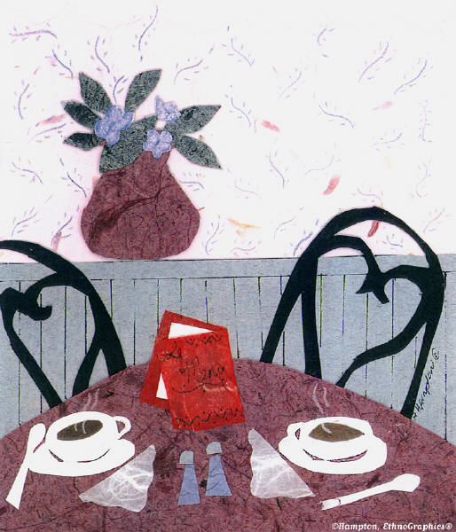
4/5 Blenheim Terrace, Scarborough, Tel 01723 374884

